GMV Portfolio - Python Code and Explanation
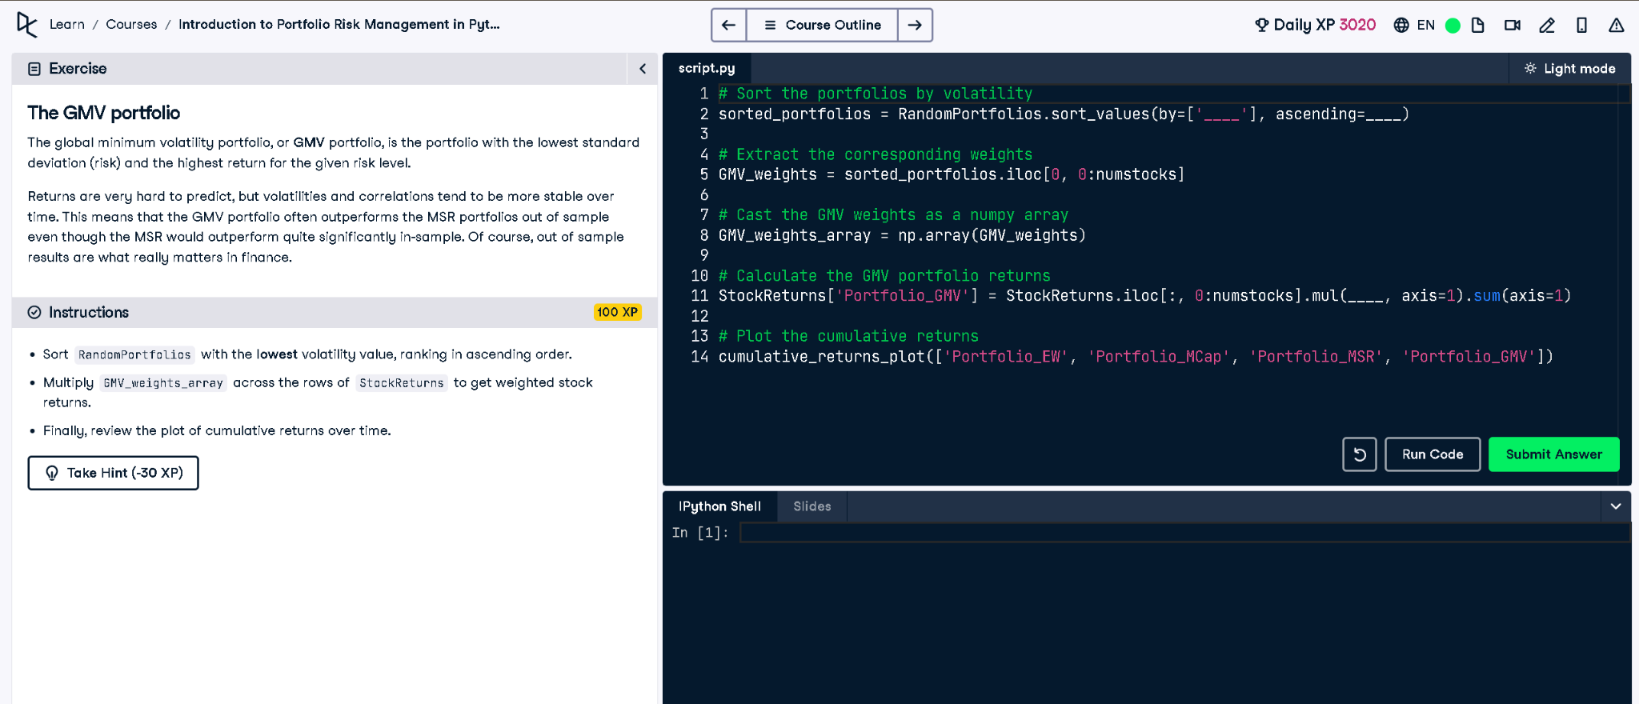

Python Code
# Sort the portfolios by volatility
sorted_portfolios = RandomPortfolios.sort_values(by=['Volatility'], ascending=True)
# Extract the corresponding weights
GMV_weights = sorted_portfolios.iloc[0, 0:numstocks]
# Cast the GMV weights as a numpy array
GMV_weights_array = np.array(GMV_weights)
# Calculate the GMV portfolio returns
StockReturns['Portfolio_GMV'] = StockReturns.iloc[:, 0:numstocks].mul(GMV_weights_array, axis=1).sum(axis=1)
# Plot the cumulative returns
cumulative_returns_plot(['Portfolio_EW', 'Portfolio_MCap', 'Portfolio_MSR', 'Portfolio_GMV'])

Explanation (in simple words)
The GMV (Global Minimum Volatility) portfolio has the lowest risk. To build it, we sort portfolios by volatility (lowest first), extract the corresponding weights, and calculate returns by multiplying those weights with stock returns. Finally, we plot cumulative returns and compare GMV with other portfolios.

